**When covid hit, I suddenly had a lot of time on my hands.** I decided that I was going to spend it working on myself and that I was going to use it to learn the basics of at least a programming language. I ended up learning basic Python, html, CSS, and some JavaScript. Before the shutdown, I only knew how to work with Matlab and felt like my ignorance of programming was one of my weaknesses, so I started taking steps towards fixing it. Now, I have a better understanding of the inner workings of programming, and I can contribute when people are talking about their projects. Or at least, I can follow along with what they are doing. Additionally, I was able to use my crappy 3D printed to build a better 3D printer (kind of a theme with me). I also started working on many of the projects on this site. Eventually, I want to fill my house with over-engineered gadgets that do everything for me, but that’s a story for another day.

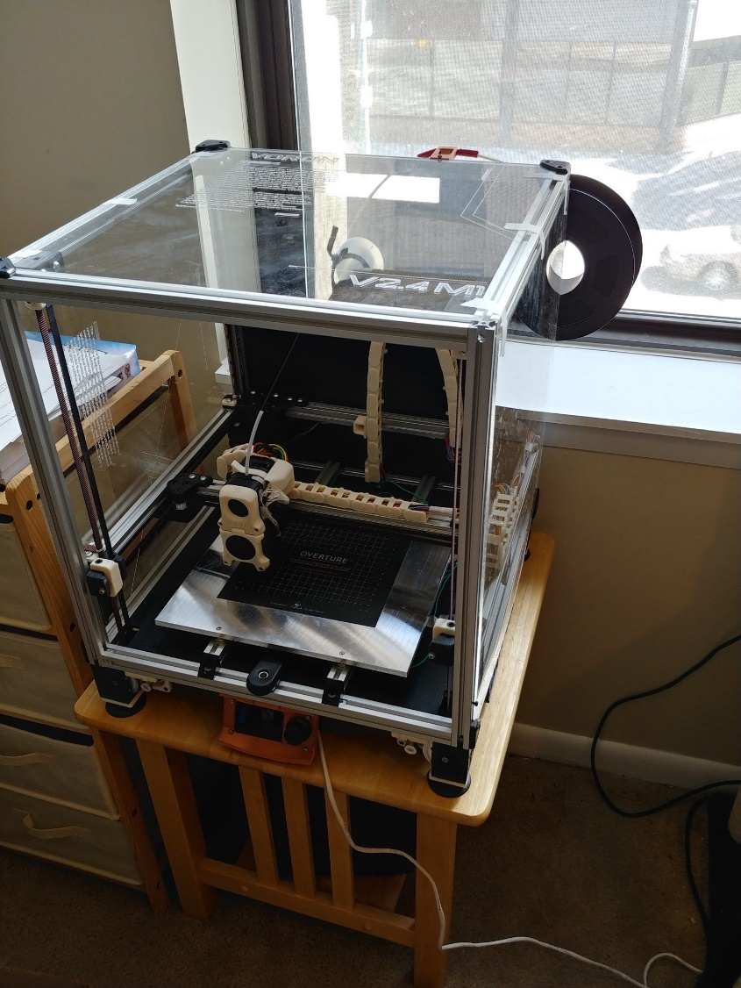

The 3D printer I built with my extra time during (and after) the Covid lockdowns

As you go through the projects on my site, you may notice the underlying goal behind all of them (aside from being fun to make). Most projects for me to try something new, learn some new skills, and maybe build a tool or two. At the end of the day, I really like making stuff (even out of the realm of engineering) and I want to do it to the best of my abilities.

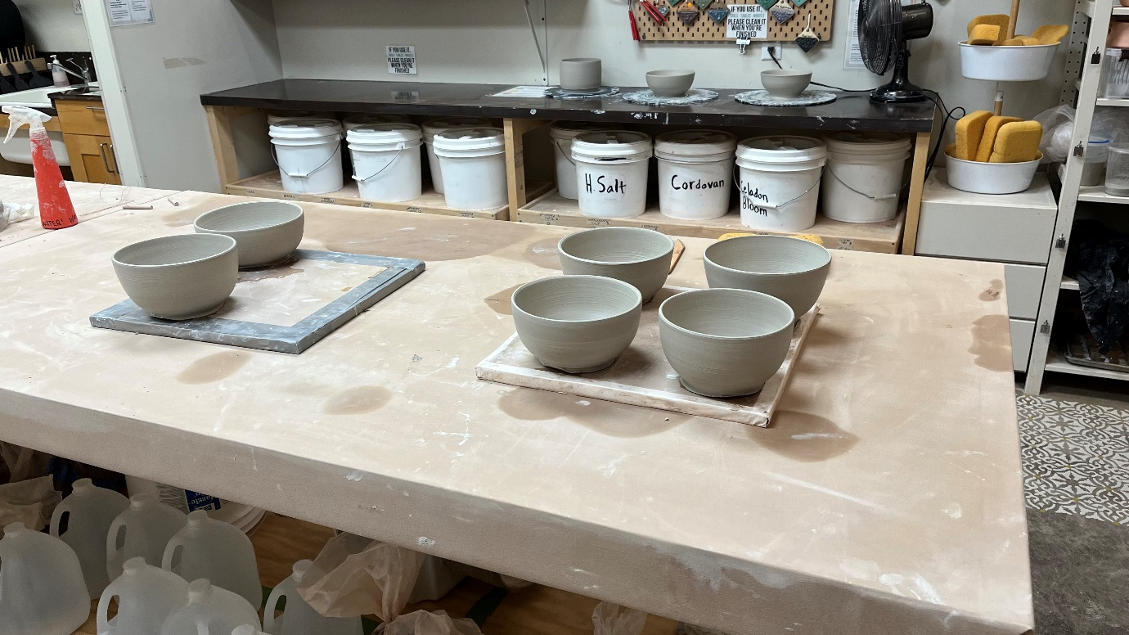

Pottery Some extracurricular activity

Learning to weld

If you would like to see more photos, take a look at my gallery. For my projects, try the projects page!

I have a friend who is a keyboard aficionado and my addiction with keyboards started because I wanted to make him SUFFER.

This chain of projects has been going on over the past few years and may have a new CNC machined iteration coming out in the near future! So, to jump right in, my first keyboard:

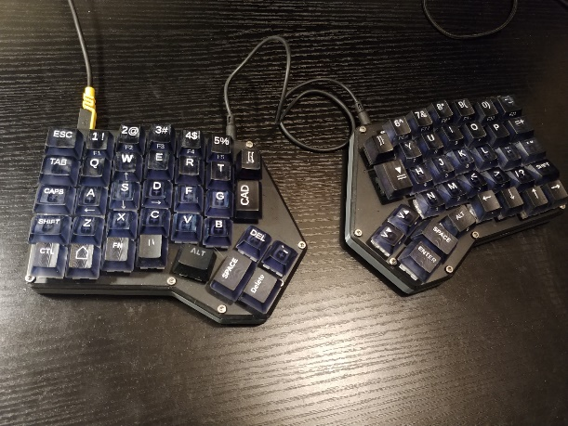

Ortholinear split keyboard with Kailh Green switches for extra click

This was a design I found online, so I will keep it brief. This was my introduction to the world of building keyboards and most of the difficulty for me was the volume of solder joints and learning how to build the firmware for the machine.

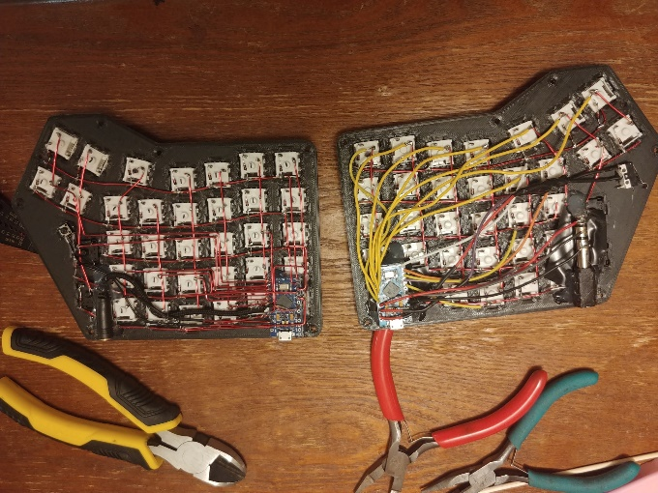

Yes, this entire keyboard was hand soldered! You can see I did the left side first and had it figured out by the time I got to the right.

The unique thing I did in this design was 3D printing everything, even the keycaps. I had just gotten a cheap resin printer online, and when I have a new toy, I find any excuse I can to use it! I ended up dying a clear resin with a deep transparent blue. After printing, I painted the lettering, cleaned it up, and finished things off with a few layers of clear coat. When I was done, my aficionado friend called me a monster. (“They switches aren’t even lubricated and ...well... just look at it!”)

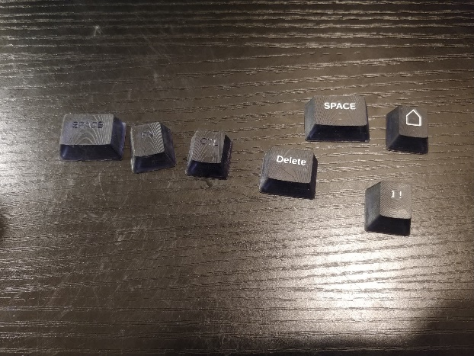

Keycaps in progress.

My next board was one that I designed entirely myself. This time I didn’t print the keycaps, but I did have to contend with the limits of my printer’s volume.

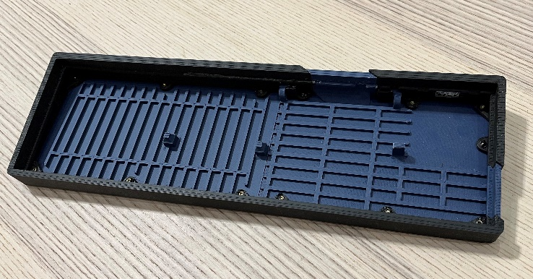

If you notice, the top right corner is a separate part from the rest of the keyboard. Printer sizing shenanigans.

Again, my friend wasn’t a fan of this decision from an aesthetics or keyboard rigidity standpoint. I can’t disagree that cutting the keyboard down the middle makes it less rigid (and 3D printing if for that matter). However, I can’t tell the different between this and “rigid” boards so it still meets the requirements specified by the end user, me. Also, I think it looks pretty cool.

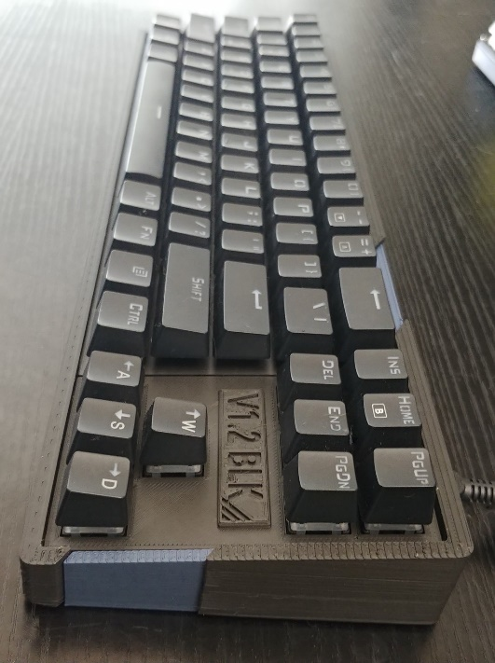

Finished product.

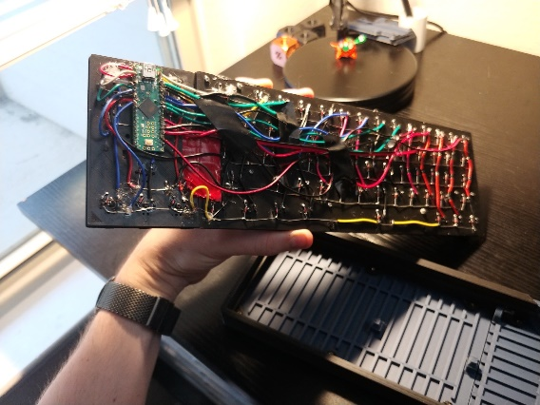

I didn’t fix the spaghetti wiring on this one either…

For my most recent board, I wanted to do something about my spaghetti wiring so I learned how to use KiCad and got some proper PCBs made with JLCPCB.

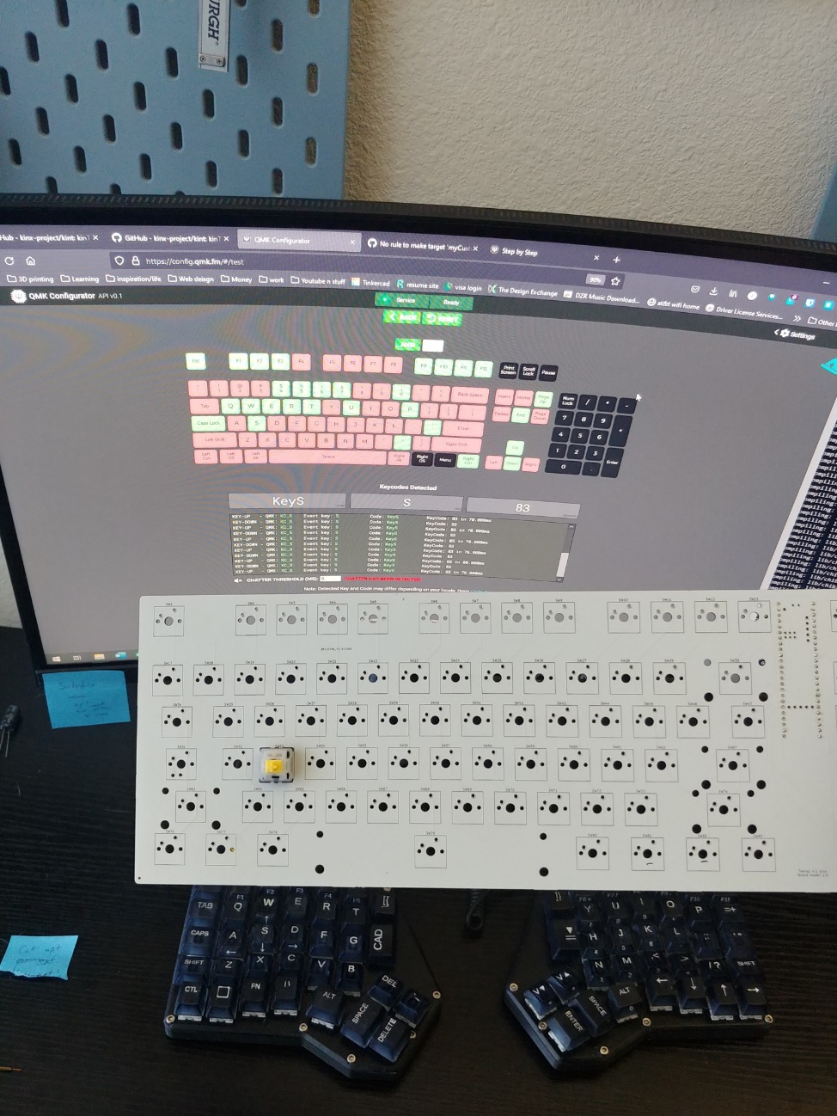

The moment of truth! The wiring worked!

I also updated the design to a simpler case – aesthetically and from a design standpoint. And apparently my friend was right about the mushy feeling of my last keyboard. I was using it as my daily driver at work and it was slowly driving me crazy! With a stiff PCB backing the keys and a short load path to the table, this board is much more rigid than the last and has been my daily driver ever since!

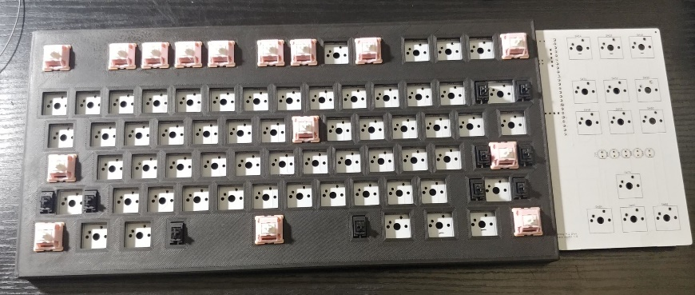

Test fitting the keycaps and stabilizers. I hadn’t made a PCB before, but I managed to get it right on the first try!

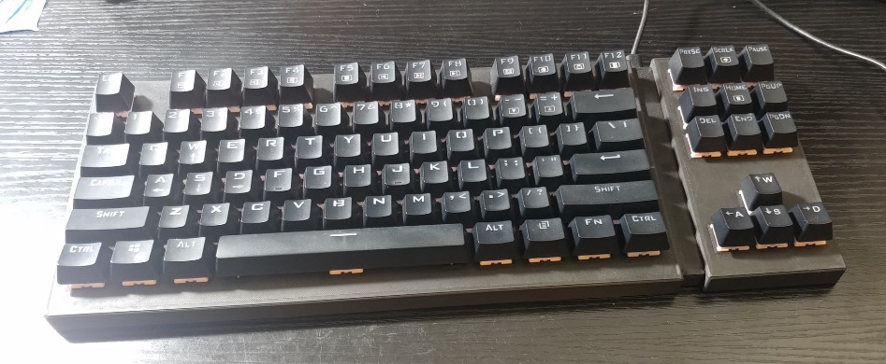

Finished assembly.

This project is still in process, and the next iteration of keyboard is pending. The CAD has been finished as of 7/25/2023, and now I need to get some material to prototype it.

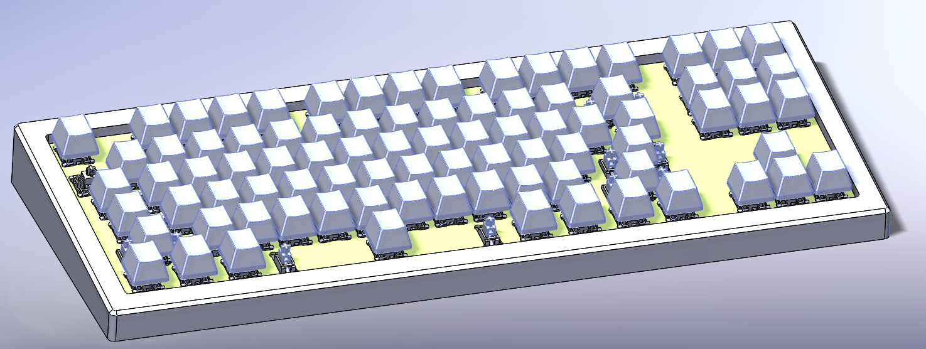

Sneak peek at the new design. Please ignore the weirdly sized keycaps, they are just for reference.